|  |
| --- |
| C:\Users\Tsubaki Yukino\Desktop\FlyAwayPlus Project\Capture.JPG |
| **IVOLUNTEER** |
| **Software Requirement Specification** |
|  |
| |  |  |  | | --- | --- | --- | | **IVOLUNTEER** | | | | **Group Members** | Nguyen Minh Duc |  | | Nguyen Thac Son |  | | Vo Ton Phuc |  | | Pham Van Trong |  | | Nguyen Van Tam |  | | **Supervisor** | Mr. Bui Dinh Chien | | | **Project code** | IVSN | | |
|  |

**Hanoi, May 28th 2016**

**RECORD OF CHANGE**

*A-Added; M-Modified; D-Deleted

|  |  |  |  |  |
| --- | --- | --- | --- | --- |
| **Effective Date** | **Change Items** | **A*M, D** | **Change Description** | **New Version** |
| 28/5/2016 | Functional Requirement | A |  | v1.0 |
| Non-functional Requirement | A |  |
|  |  |  |  |  |
|  |  |  |  |  |
|  |  |  |  |  |

Table 1.1‑1 Record of change

**SIGNATURE PAGE**

|  |  |  |
| --- | --- | --- |
| **ORIGINATOR** | Nguyen Van Tam |  |
|  | Developer |  |
|  |  |  |
|  |  |  |
| **REVIEWERS** | Nguyen Minh Duc |  |
|  | Project Manager |  |
|  |  |  |
|  |  |  |
| **APPROVAL** | Mr. Bui Dinh Chien |  |
|  | Supervisor |  |
|  |  |  |

Table of Contents

**1.** **INTRODUCTION** 6

1.1. Purpose 6

1.2. Definitions and Acronyms 6

1.3. System Purpose 6

**2.** **OVERALL DESCRIPTION** 7

2.1. System overview 7

2.2. Use Case Diagram 7

2.3. Product Features 7

2.3.1. User Characteristics 7

2.3.2. User Documentation **Error! Bookmark not defined.**

2.3.3. Assumption **Error! Bookmark not defined.**

2.4. Entity Relation Model 8

2.4.1. Entity-Relationship Diagram 8

2.4.2. Entity Detail 9

**3.** **FUNCTIONAL SPECIFICATION** 9

3.1. Appendix **Error! Bookmark not defined.**

3.2. Business Rules 9

3.3. Use Cases 9

3.3.1. Common Module **Error! Bookmark not defined.**

3.3.2. Suggest Module **Error! Bookmark not defined.**

3.3.3. Social Module **Error! Bookmark not defined.**

3.3.4. Account Management Module **Error! Bookmark not defined.**

3.3.4.1. Login **Error! Bookmark not defined.**

3.3.4.2. UC049-Logout **Error! Bookmark not defined.**

3.3.4.3. UC050-Register **Error! Bookmark not defined.**

3.3.4.4. UC051-Edit profile **Error! Bookmark not defined.**

3.3.4.5. UC052-Forgot password **Error! Bookmark not defined.**

3.3.5. Admin Module **Error! Bookmark not defined.**

3.3.5.1. UC053-Lock user’s account **Error! Bookmark not defined.**

3.3.5.2. UC054-Unlock user’s account **Error! Bookmark not defined.**

3.3.5.3. UC055-Send warning **Error! Bookmark not defined.**

3.3.5.4. UC056-Review user **Error! Bookmark not defined.**

3.3.5.5. UC057-Review post **Error! Bookmark not defined.**

3.3.5.6. UC058-Delete user’s post **Error! Bookmark not defined.**

3.3.5.7. UC059-Reply question **Error! Bookmark not defined.**

**4.** **NON-FUNCTIONAL SPECIFICATION** 40

Reliability 40

Performance Requirements 40

User Interface 40

Maintainability 40

Usability 41

Security Requirements 41

Hardware/Software Requirements 41

# **INTRODUCTION**

## Purpose

This is the Software Requirements Specification for the IVSN system. This document will provide the describing of general requirement and non-functional requirements of our IVSN system. The IVSN is designed to be a web application that creates a platform to help people who have abilities and interests in volunteer activities. These requirements will assure that the system will correctly and reliably perform its intended functionality. This specification will provide general, as well as specific requirements to be used in the design, testing and validation of the system. It is intended for both stakeholders and the project team of the system.

## Definitions and Acronyms

|  |  |
| --- | --- |
| Terms | Description |
| IVSN | IVolunteer Social Network |
| Project | Volunteering project that Registered User/ Group Leader created in the IVSN system |
| Group | Volunteering group that User created in the IVSN system |
| Donator | User who made a donation request to Project |

Table 1.2‑1 Definition and Acronyms

## System Purpose

We expect that the IVSN system will become a place for volunteer in the whole country gathering, communicating or sharing their experience, their emotion about volunteering. A place can run volunteer project in all domains. A place supports all activities of volunteering such as: finding volunteers, calling for donate, contribution, communication on project. It helps volunteer activity become simple and more efficient.

# **OVERALL DESCRIPTION**

## System overview

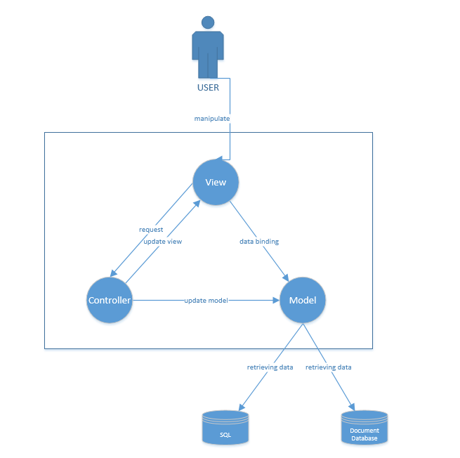

## Use Case Diagram

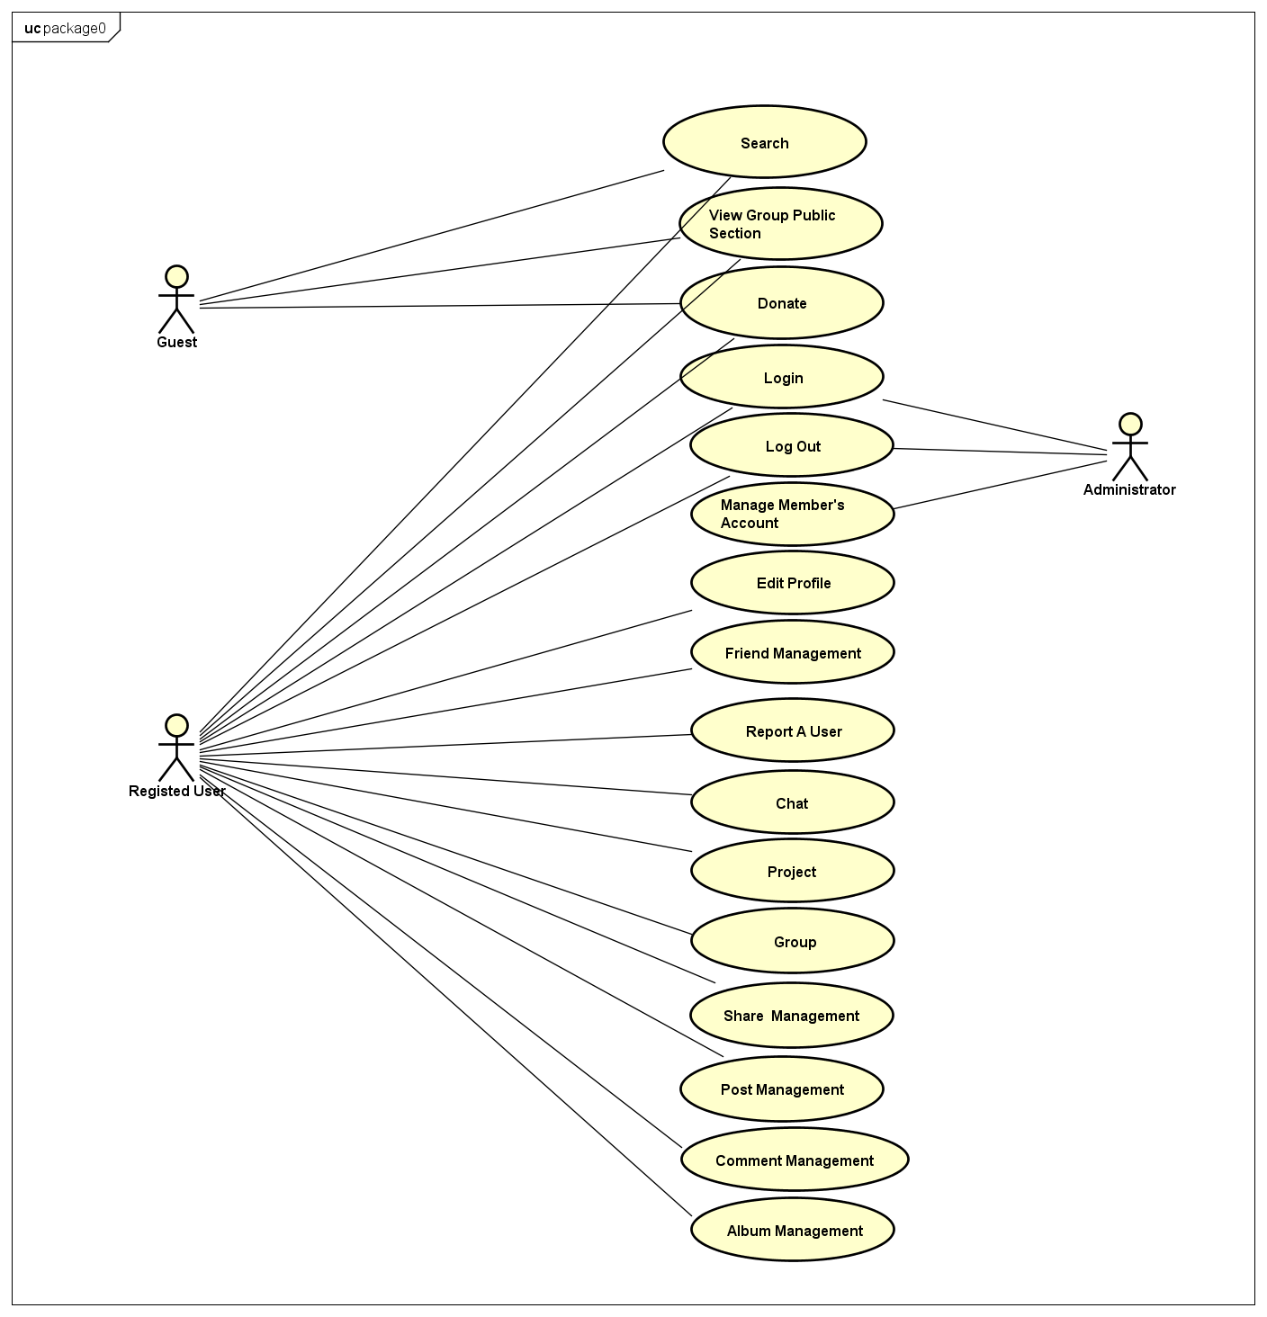

Figure 2-1: Use case diagram of IVSN system

## Product Features

### User Characteristics

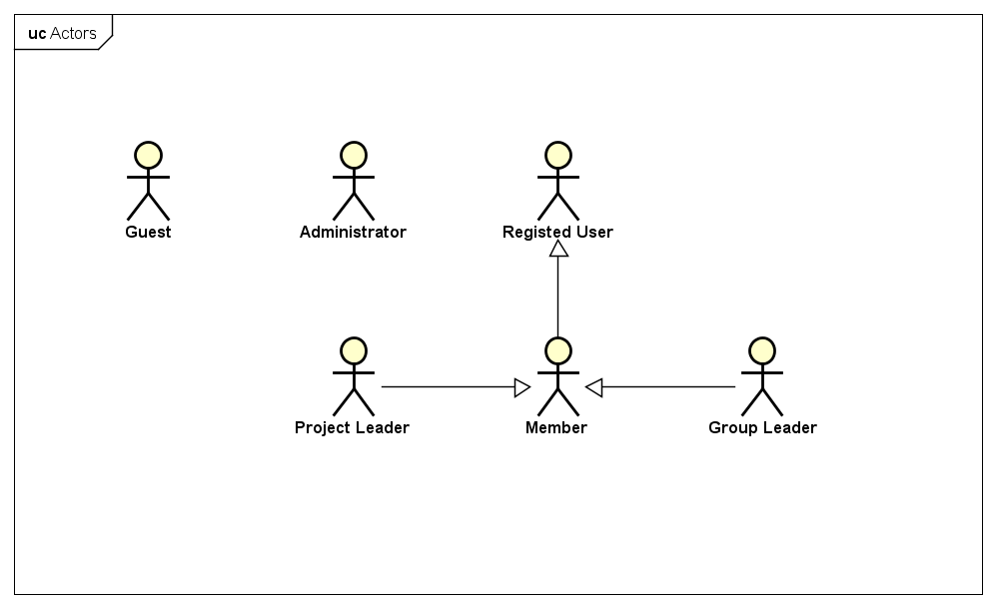

Figure 2‑1 Actors in the IVSN system

* **Guest**: Guest is anyone who access into the IVSN system. They are allowed to view all project information that is public in the system. They can use advanced search function to search for project that match with their interests, conditions.
* **Administrator**: Administrator has the most authority over the IVSN system. Administrator has right to ban or reactive Registered User, Group and Group in the system.
* **Registered User**: Registered User is user who owns account in the system and logged in into the system. They can join or making a donation to a project. They can follow a Group, or a Project to get updated activity information and make friend with other User in the system. They have right to create a Group, a Project in the system; invite their friend to join into a Group, a Project.
* **Member**: Member is user who has joined a Group or a Project. Members in a Group or a Project discuss with the others by write a post. They are automatically got their Group/Project’s new posts, their task assignment appeared in their Homepage. They have right to suggest their friend to their Group/Project and create album, update photo to created Album.
* **Group Leader**: Group Leader is user who creates a Group in the system. Group Leader has right to update Group information, represent his Group to create new Project, join his Group to another Project, assign Group Leader, remove User from Group and approve User to be a Group member.
* **Project Leader**: User who creates a project will become a Project Leader. Project Leader can create and update information, plan of the project. They have right to assign Project Leader, remove User from Project and are responsible for communicate with User who sent request to donate to Project.

## Entity Relation Model

### Entity-Relationship Diagram

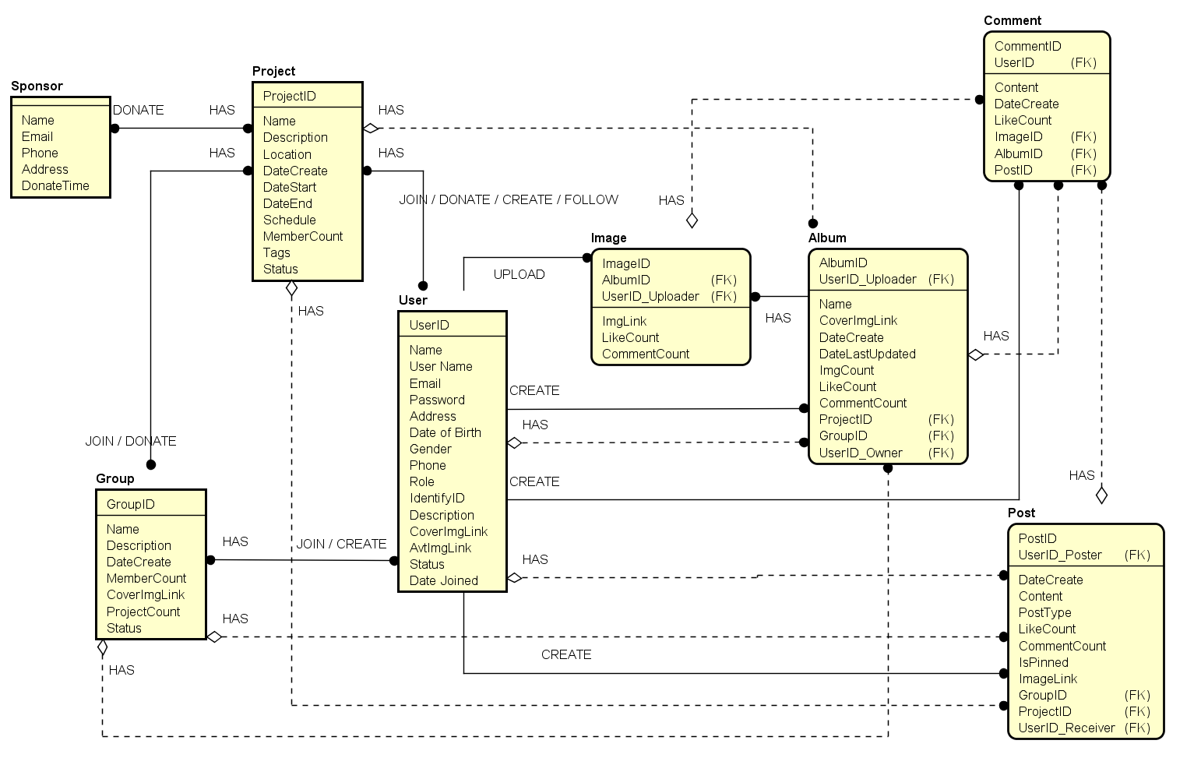

Entity Relationship Diagram part 1

### Entity Detail

#### Sponsor

|  |  |  |  |  |
| --- | --- | --- | --- | --- |
| No | Attribute | Type | Mandatory | Description |
|  | Sponsor ID | Number | Y | Sponsor’s id |
|  | Name | Number | Y | Sponsor’s name |
|  | Email | String | Y | Sponsor’s email |
|  | Address | String | Y | Sponsor’s address |
|  | Phone | Number | Y | Sponsor’s phone |
|  | Donate Time | Number | Y | Sponsor’s donate time |

#### Project

|  |  |  |  |  |
| --- | --- | --- | --- | --- |
| No | Field Name | Type | Mandatory | Description |
|  | Project ID | Number | Y | Project’s id |
|  | Name | String | Y | Project’s name |
| 3 | Description | String | Y | Project’s description |
| 4 | Location | String | Y | Project’s location |
| 5 | Date Created | Date | Y | Project’s date created |
| 6 | Date Start | Date | Y | Project’s date start |
| 7 | Date End | Date | Y | Project’s date end |
| 8 | Schedule | String | Y | Project’s schedule |
| 9 | Member Count | Number | Y | Project’s member count |
| 10 | Tags | String | Y | Project’s tags |
| 11 | Status | Number | Y | Project’s status |

#### Group

|  |  |  |  |  |
| --- | --- | --- | --- | --- |
| No | Field Name | Type | Mandatory | Description |
|  | Group ID | Number | Y | Group’s id |
|  | Name | String | Y | Group’s name |
|  | Description | String | Y | Group’s description |
|  | Date Created | Date | Y | Group’s date created |
|  | Member Count | Number | Y | Group’s member count |
|  | Cover Img Link | String | Y | Group’s cover img link |
|  | Project Count | Number | Y | Group’s project count |
|  | Status | String | Y | Group’s status |

#### Post

|  |  |  |  |  |
| --- | --- | --- | --- | --- |
| No | Field Name | Type | Mandatory | Description |
|  | Post ID | Number | Y | Post’s id |
|  | Content | String | Y | Post’s content |
|  | Date Create | Date | Y | Post’s date create |
|  | User ID Poster | Number | Y | Post’s user id poster |
|  | Post Type | String | Y | Post’s post type |
|  | Like Count | Number | Y | Post’s like count |
|  | Comment Count | Number | Y | Post’s comment count |
|  | Is Pinned | Boolean | Y | Post’s is pinned |
|  | Image Link | String | Y | Post’s image link |
|  | Group ID | Number | Y | Post’s group id |
|  | Project ID | Number | Y | Post’s project |
|  | UserID Receiver | Number | Y | Post’s userid reciver |

#### Image

|  |  |  |  |  |
| --- | --- | --- | --- | --- |
| No | Field Name | Type | Default | Description |
|  | Image ID | Number | Y | Image’s id |
|  | Album ID | String | Y | Image’s album id |
|  | UserID Uploader | Number | Y | Image’s user id uploader |
|  | Image Link | String | Y | Image’s link |
|  | Like Count | Number | Y | Image’s like count |
|  | Comment Count | Number | Y | Image’s comment count |

#### Album

|  |  |  |  |  |
| --- | --- | --- | --- | --- |
| No | Field Name | Type | Mandatory | Description |
|  | Album ID | Number | Y | Album’s id |
|  | User ID Uploader | String | Y | Album’s path |
|  | Date create | Date | Y | Album’s date created |
|  | Name | String | Y | Album’s name |
|  | Cover Image Link | String | Y | Album’s cover img link |
|  | Date Last Update | Date | Y | Album’s date last update |
|  | Image Count | String | Y | Album’s Image count |
|  | Like Count | Number | Y | Album’s like count |
|  | Comment Count | Number | Y | Album’s comment count |
|  | Project ID | Number | Y | Album’s project id |
|  | Group ID | Number | Y | Album’s group id |
|  | User ID Owner | Number | Y | Album’s userid owner |

#### Comment

|  |  |  |  |  |
| --- | --- | --- | --- | --- |
| No | Field Name | Type | Mandatory | Description |
|  | Comment ID | Number | Y | Comment’s id |
|  | Content | String | Y | Comment’s content |
|  | Date Created | Date | Y | Comment’s date created |
|  | User ID | Number | Y | Comment’s user id |
|  | Like count | Number | Y | Comment’s like count |
|  | Image ID | Number | Y | Comment’s image id |
|  | Album ID | Number | Y | Comment’s album id |
|  | Post ID | Number | Y | Comment’s post id |

#### User

|  |  |  |  |  |
| --- | --- | --- | --- | --- |
| No | Field Name | Type | Mandatory | Description |
|  | User ID | Number | Y | User’s id |
|  | Name | String | Y | User’s name |
|  | User Name | String | Y | User’s user name |
|  | Email | String | Y | User’s email |
|  | Password | String | Y | User’s password |
|  | Address | String | Y | User’s address |
|  | Gender | String | Y | User’s gender |
|  | Phone Number | String |  | User’s phone number |
|  | Date of Birth | Date | Y | User’s date of birth |
|  | Identify ID | String | Y | User’s identify id |
|  | Status | String | Y | User’s status |
|  | Date Joined | Date | Y | User’s date joined |
|  | Role | String | Y | User’s role |
|  | Description | String | Y | User’s description |
|  | Cover Img Link | String | Y | User’s cover img link |
|  | Avt Img Link | String | Y | User’s avt img link |

# **FUNCTIONAL SPECIFICATION**

## Business Rules

## Use Cases

### Homepage

#### View Project

|  |  |  |  |
| --- | --- | --- | --- |
| UC ID and Name | **UC101 View Project** | | |
| Created By | TamNV | Date Created: | May 28th 2016 |
| Primary Actor | **Guest** | Secondary Actor | **Registered User** |
| Trigger | User saw a Project post displayed in Homepage then he indicates to view Project details. | | |
| Description | When user accessed to the system, they can see some Project posts that are suggested in the Homepage. If they want to see more details about one Project such as Project’s objective, plan, activities, they can click on that Project post to view all these detail information. | | |
| Preconditions | **P001** User accessed successfully into the IVSN system. | | |
| Post conditions | **P101** Project page are displayed. | | |
| Normal Flow | 1. User click on Project post 2. The IVSN system redirects user to Project page. | | |
| Alternative Flows | N/A | | |
| Exception | **E101** System cannot load Project details page   1. The IVSN indicates that problem occurs in Internet connection. 2. Message “Cannot load page” is displayed. | | |
| Priority | High | | |
| Frequency of Use | High | | |
| Business Rules | None | | |
| Other Information | None | | |
| Assumptions | None | | |

Table 3.2‑1

#### Search for User/Group/Project

|  |  |  |  |
| --- | --- | --- | --- |
| UC ID and Name | **UC102 Search for User/Group/Project** | | |
| Created By | TamNV | Date Created: | May 28th 2016 |
| Primary Actor | **Registered User** | Secondary Actor | **Guest** |
| Trigger | User indicates to find User/Group/Project by its name. | | |
| Description | When User wants to find if another Registered User, a Group or a Project is in the system, User can enter its name as keyword to Search bar. Search results are simultaneously displayed as User typing.  User can click on one item in Search Result (if any) to view User profile page (if item is User), Group page (if item is Group) or Project page (if item is Project) | | |
| Preconditions | **P001** | | |
| Post conditions | **P102** A list of search results is displayed | | |
| Normal Flow | 1. User enters a name into Search bar. 2. The IVSN system returns a list of search results. 3. User clicks on one item in search results. 4. The IVSN system redirects user to Search Page. | | |
| Alternative Flows | N/A | | |
| Exception | **E102.1** Problem occurs in step 2.   * 1. The IVSN system indicates that problem occurs in Internet connection.   2. Loading icon is displayed in list of search results.   **E102.2** Problem occurs in step 4.   * 1. The IVSN system indicates that problem occurs in Internet connection.   2. Message “Cannot load page” is displayed. | | |
| Priority | High | | |
| Frequency of Use | High | | |
| Business Rules | **B1.** Maximum number of character in Search bar is | | |
| Other Information | None | | |
| Assumptions | None | | |

Table 3.2‑2

#### Advanced search for Project

|  |  |  |  |
| --- | --- | --- | --- |
| UC ID and Name | **UC103 Advanced search for Project** | | |
| Created By | TamNV | Date Created: | May 28th 2016 |
| Primary Actor | **Guest** | Secondary Actor | **Registered User** |
| Trigger | User indicates to find Project by using attribute filter. | | |
| Description | Since Project posts that are displayed in Homepage is limited and might not suit with User’s desires. User can search for Project by entering Project’s date, sector or destination. If there any result found, user can click on that result to view more detail. | | |
| Preconditions | **P001** | | |
| Post conditions | **P102** | | |
| Normal Flow | 1. User click on Advanced search button 2. The IVSN system displays filter box. 3. User enters value in one of filter attributes. 4. The IVSN system redirects user to Search Page. | | |
| Alternative Flows | N/A | | |
| Exception | **E103** User does not enter any value of filer attributes.   * 1. User enters no value in any of filter attributes.   2. The IVSN system display message “You have to fill into at least one attribute.” | | |
| Priority | High. | | |
| Frequency of Use | High. | | |
| Business Rules | **B2** Filter attribute include “Project name”, “Destination”, “Period of time”, “Sector”.  **B3** Project name  **B4** Destination includes Vietnam 63 cities, provinces.  **B5** Sector includes “Education”, ”Examination season support ”, ”Health care”, ”Disaster ”, ”Environment”, ””, ”” | | |
| Other Information | None. | | |
| Assumptions | None. | | |

Table 3.2‑3

#### View experience story

|  |  |  |  |
| --- | --- | --- | --- |
| UC ID and Name | **UC104 View experience story** | | |
| Created By | TamNV | Date Created: | May 28th 2016 |
| Primary Actor | **Guest** | Secondary Actor |  |
| Trigger | User indicates to view volunteer related experience story that are public in the IVSN system. | | |
| Description | User accessed to the system might want to view all the experience stories that are published by Registered User in the system. These stories are ranked by “Like” unit graded by Registered User. User click on one story to see more detail. | | |
| Preconditions | **P001** | | |
| Post conditions | **P104** Story is displayed. | | |
| Normal Flow | 1. User clicks on “Experience Story” in Master bar. 2. The IVSN system redirects user to Experience story page. 3. User clicks on one item in Story list. 4. The IVSN system redirect user to Story detail page. | | |
| Alternative Flows | N/A | | |
| Exception | **E104.1**   * 1. The IVSN indicates that problem occurs in Internet connection.   2. The IVSN system display “Cannot display page” | | |
| Priority | High | | |
| Frequency of Use | High | | |
| Business Rules |  | | |
| Other Information | None | | |
| Assumptions | None | | |

Table 3.2‑4

### Authentication

#### Register account

|  |  |  |  |
| --- | --- | --- | --- |
| UC ID and Name | **UC201 Register Account** | | |
| Created By | TamNV | Date Created: | May 28th 2016 |
| Primary Actor | **Guest** | Secondary Actor |  |
| Trigger | User indicate to use extend function of the IVSN system. | | |
| Description | In order to participate in Project in the system and use other function such as create Group, create Project, comment on Project post. User is required to Login. For those who don’t own an account. They have to register.  In registration page, use is required to enter their basic information (Full name, email, password, address, date of birth, phone number) and Volunteering related information (Interested Sector, skills, ) | | |
| Preconditions | **P001** | | |
| Post conditions | **P201** User is logged successfully into the IVSN system. | | |
| Normal Flow | 1. User click on Register button. 2. The IVSN system redirect user to Registration page. 3. User enters required basic information. 4. User enters volunteering related information. 5. The IVSN checks the validation of entered information. 6. User clicks on “Register” button. 7. The IVSN system redirects user to Homepage. | | |
| Alternative Flows | User skip entering volunteering related information   * 1. User skips entering volunteering related information.   2. The IVSN checks the validation of entered information.   3. User clicks on “Register” button.   4. The IVSN system redirects user to Homepage. | | |
| Exception | **E201.1** User does not enters all required basic information.   * 1. The IVSN system displays message “This is required information” after required attributes   **E201.2** User enters Email address that already existed in the system  6.1. The IVSN systems display message “This email already existed” after required attributes | | |
| Priority | High. | | |
| Frequency of Use | High. | | |
| Business Rules | **B6** Required information including “”,“”,“”,“”,“”,“”,  **B7** Volunteering related information including “”,“”,“”,“”,“”, | | |
| Other Information | None. | | |
| Assumptions | None. | | |

Table 3.2‑5

#### Log in

|  |  |  |  |
| --- | --- | --- | --- |
| UC ID and Name | **UC202 Log in** | | |
| Created By | TamNV | Date Created: | May 28th 2016 |
| Primary Actor | Registered User | Secondary Actor |  |
| Trigger | User indicates to log in the IVSN system. | | |
| Description | Users log in to the system become to be able to use full feature of the system including create Group/Project, join Project, make friend, interact with Member in Group/Project, mange profile information and others. | | |
| Preconditions | **P002** User already owns an account in the IVSN system. | | |
| Post conditions | **P202** User is successfully logged in the IVSN system. | | |
| Normal Flow | 1. User click on “Log in” button. 2. The IVSN systems displays “Log in” box. 3. User enters Email Address, Password. 4. The IVSN system checks validation of entered Email Address and Password 5. The IVSN redirects user to Homepage. | | |
| Alternative Flows | N/A | | |
| Exception | **E202** User enter the wrong Email Address or Password   * 1. The IVSN display message “Email Address or Password is not correct” | | |
| Priority | High. | | |
| Frequency of Use | High. | | |
| Business Rules |  | | |
| Other Information | None. | | |
| Assumptions | None. | | |

Table 3.2‑6

#### Log out

|  |  |  |  |
| --- | --- | --- | --- |
| UC ID and Name | **UC203 Log out** | | |
| Created By | TamNV | Date Created: | May 28th 2016 |
| Primary Actor | Registered User | Secondary Actor |  |
| Trigger | User indicates to log out of the IVSN system. | | |
| Description | For some reason User might want to log out of the system. | | |
| Preconditions | **P202** | | |
| Post conditions | **P203** User is logged out of the IVSN system. | | |
| Normal Flow | 1. User click on “Log out” button. 2. The IVSN system redirects user to Homepage as a Guest. | | |
| Alternative Flows | N/A | | |
| Exception | N/A | | |
| Priority | High. | | |
| Frequency of Use | High. | | |
| Business Rules | None. | | |
| Other Information | None. | | |
| Assumptions | None. | | |

Table 3.2‑7

### Group

#### Create Group

|  |  |  |  |
| --- | --- | --- | --- |
| UC ID and Name | **UC301 Create Group** | | |
| Created By | TamNV | Date Created: | May 28th 2016 |
| Primary Actor | **Registered User** | Secondary Actor |  |
| Trigger | User indicates to open a group in the IVSN system for gathering member to do volunteering activities. | | |
| Description | Simulate Volunteering Group in real life, User can register to create a Group in the system then become a Group Leader. Group Page is where allows Group Leader, Group members to invite their Friend to join Group, where all members discuss with other about Volunteering activities. | | |
| Preconditions | **P202** | | |
| Post conditions | **P301** User is redirected in the Group Page as the role of Group Leader. | | |
| Normal Flow | 1. User click on “Create Group” button. 2. The IVSN systems redirects user to “Group registration page”. 3. User enters required information. 4. The IVSN system validates entered information. 5. User clicks on “Create” button. 6. The IVSN system redirects user to Group Page as the role of Group Leader. | | |
| Alternative Flows | User cancel the registration  5.1. User clicks on “Cancel” button  5.2. The IVSN system redirects back to Homepage. | | |
| Exception | **E301.1** User does not enter all required information or the  5.1. The IVSN system display message “This is required information.”  **E301.2** User entered information that has already existed in the system.  5.1 The IVSN system display message “This name is already existed.” | | |
| Priority | High. | | |
| Frequency of Use | High. | | |
| Business Rules | None. | | |
| Other Information | None. | | |
| Assumptions | None. | | |

Table 3.2‑8

#### Update Group Page information

|  |  |  |  |
| --- | --- | --- | --- |
| UC ID and Name | **UC302** | | |
| Created By | TamNV | Date Created: | May 28th 2016 |
| Primary Actor | **Group Leader** | Secondary Actor |  |
| Trigger | User indicates to update Group information that User has not provide or out-of-date Group information. | | |
| Description | For some reasons Group Leader might want to change Group Page information (including Group name, slogan, objective, rule and Group profile picture). | | |
| Preconditions | **P301** | | |
| Post conditions | **P302** Group information is successfully updated. | | |
| Normal Flow | 1. User click on “Group information” button. 2. The IVSN system redirected User to “Group information page”. 3. User updates contents. 4. User clicks on “Update” button. 5. The IVSN system updates entered information. | | |
| Alternative Flows | User cancels the process.   * 1. User clicks on “Cancel” button.   2. The IVSN system cancels all entered information. | | |
| Exception | N/A | | |
| Priority | High. | | |
| Frequency of Use | High. | | |
| Business Rules | **B8 Group information including “”,“”,“”,“”,** | | |
| Other Information | None. | | |
| Assumptions | None. | | |

Table 3.2‑9

#### Assign Group Leader

|  |  |  |  |
| --- | --- | --- | --- |
| UC ID and Name | **UC303 Assign Group Leader.** | | |
| Created By | TamNV | Date Created: | May 28th 2016 |
| Primary Actor | **Group Leader** | Secondary Actor |  |
| Trigger | User indicates to assign another member in Group to Group Leader. | | |
| Description | Group Leader can assign role Leader to other members in Group to help him administrate Group.  New Assigned Group Leader will share the same authority with the old one. | | |
| Preconditions | **P301,** user accessed into “Member page” | | |
| Post conditions | Assigned Member became Group Leader. | | |
| Normal Flow | 1. User click on “Assign Group Leader” button in a specific member item. 2. The IVSN systems make assigned member become Group Leader. 3. The IVSN systems notifies to assigned member. | | |
| Alternative Flows | N/A | | |
| Exception | N/A | | |
| Priority | High. | | |
| Frequency of Use | High. | | |
| Business Rules |  | | |
| Other Information | None. | | |
| Assumptions | None. | | |

Table 3.2‑10

#### Approve user to Group

|  |  |  |  |
| --- | --- | --- | --- |
| UC ID and Name | **UC304 Approve user to Group** | | |
| Created By | TamNV | Date Created: | May 28th 2016 |
| Primary Actor | **Group Leader** | Secondary Actor |  |
| Trigger | User indicates to approve user request to join group. | | |
| Description | If there is a request from other User wants to join Group. Group Leader after scanning his information by viewing his Profile page, has right to accept this request (this action adds User as a Group member in to Group), otherwise deny request (User is not added into Group). | | |
| Preconditions | **P301** | | |
| Post conditions | The user, who made request, became Member of the group. | | |
| Normal Flow | 1. Group Leader click on “Accept” button. 2. The IVSN system make user who requested the role of Member of the Group. 3. The IVSN system notifies to accepted user. | | |
| Alternative Flows | Group Leader deny request.   * 1. Group Leader click on “Deny” button.   2. The IVSN system remove request out of “Member Request” box. | | |
| Exception | N/A | | |
| Priority | High. | | |
| Frequency of Use | High. | | |
| Business Rules |  | | |
| Other Information | None. | | |
| Assumptions | None. | | |

Table 3.2‑11

#### Remove Member from Group

|  |  |  |  |
| --- | --- | --- | --- |
| UC ID and Name | **UC305 Remove Member from Group** | | |
| Created By | TamNV | Date Created: | May 28th 2016 |
| Primary Actor | **Group Leader** | Secondary Actor |  |
| Trigger | Group Leader indicates to remove a member of the Group. | | |
| Description | For some reasons, Group Leader might want to remove Group member out of group.  This case he accesses Group member list, then choose member to remove him from Group.  All posts that are created in this Group will no longer displayed in User’s homepage. | | |
| Preconditions | **P301** | | |
| Post conditions | Member is removed out of the Group | | |
| Normal Flow | 1. Group Leader accesses “Member page”. 2. The IVSN system redirects to “Member page”. 3. Group Leader click on “Remove member” in a specific member item. 4. The IVSN systems remove data of member out of the Group. | | |
| Alternative Flows | N/A | | |
| Exception | N/A | | |
| Priority | High. | | |
| Frequency of Use | High. | | |
| Business Rules |  | | |
| Other Information | None. | | |
| Assumptions | None. | | |

Table 3.2‑12

#### Write post in Group

|  |  |  |  |
| --- | --- | --- | --- |
| UC ID and Name | **UC306 Write post in Group** | | |
| Created By | TamNV | Date Created: | May 28th 2016 |
| Primary Actor | **Member** | Secondary Actor |  |
| Trigger | User indicates to discuss something with other Member in Group. | | |
| Description | In one Group, discussion between members is indispensable. Therefore, the system allows user to write a post in Group. Other users can interact with this post by write a comment below or press Like button to the post.  These posts are managed by Group Leader. Means that Group Leader has right to delete a post.  These posts once created, shall be displayed in Homepage of who joined this Group. | | |
| Preconditions | **P003** Member is in Group Page’s Discussion section | | |
| Post conditions | **P306** Written post is displayed in Discussion section. | | |
| Normal Flow | 1. User enters text into “Discussion box”. 2. User click on “Post” button. 3. The IVSN system validates entered data. 4. The IVSN system displays Post on “Discussion section” of the Group. | | |
| Alternative Flows | N/A | | |
| Exception | **E306** User clicks on Post button while there is nothing in box.   * 1. The IVSN system display message “There is nothing here to post” | | |
| Priority | High. | | |
| Frequency of Use | High. | | |
| Business Rules |  | | |
| Other Information | None. | | |
| Assumptions | None. | | |

Table 3.2‑13

#### Suggest Friend to Group

|  |  |  |  |
| --- | --- | --- | --- |
| UC ID and Name | **UC307 Suggest Friend to Group** | | |
| Created By | TamNV | Date Created: | May 28th 2016 |
| Primary Actor | **Member** | Secondary Actor | **Group Leader** |
| Trigger | User indicates to invite Friend to join Group. | | |
| Description | User who is already in Group can suggest their friend (nominee) to join this Group/Project by entering friend’s name in search box.  Search results are simultaneously displayed as User typing. User can click on one Friend (search result item) to send request to Group Leader/Project Leader first, if Group Leader/Project Leader accepts this nominee, the invitation request will be send to nominee.  Nominee can accept or deny this request. By accepting this request, he will join himself to the Group. | | |
| Preconditions | **P004** User is in Group page. | | |
| Post conditions | **P307** Friend is successfully added in to the Group. | | |
| Normal Flow | 1. User enters Friend’s name into “Member suggestion box”. 2. The IVSN system returns result list as user typing. 3. User clicks on one nominee in the result list. 4. User clicks on “Add” button. 5. The IVSN system sends approve request to Group Leader. 6. Group Leader Accept the request. 7. The IVSN system send invitation request to nominee. 8. Nominee accepts the invitation request. 9. Nominee is added into Group as Member. | | |
| Alternative Flows | Group Leader denies the request.   * 1. Group Leader denies the request.   2. The IVSN system removes the nominee out of Member Suggestion list.   Nominee denies the invitation request.  8.1. Nominee denies the invitation request.  8.2. The IVSN system does not add nominee into the Group. | | |
| Exception | N/A | | |
| Priority | High. | | |
| Frequency of Use | High. | | |
| Business Rules | None. | | |
| Other Information | None. | | |
| Assumptions | None. | | |

Table 3.2‑14

#### Create album

|  |  |  |  |
| --- | --- | --- | --- |
| UC ID and Name | **UC308 Create album** | | |
| Created By | TamNV | Date Created: | May 28th 2016 |
| Primary Actor | **Member** | Secondary Actor |  |
| Trigger | User indicate to create albums in Group. | | |
| Description | User can create an Album in Group/Project that related to volunteering activities.  Group Leader/ Project Leader has right to delete those albums if needed. | | |
| Preconditions | **P005** User is in the Group page’s Photos section. | | |
| Post conditions | Album is displayed in Photos section of the Group. | | |
| Normal Flow | 1. User click on “Create album” button. 2. The IVSN system displays “Album registration” form. 3. User clicks button to upload photo. 4. The IVSN system returns windows for user to choose photo from his computer. 5. User select photos to upload. 6. The IVSN system displays selected photos on “Album registration” form. 7. User enters Album information. 8. The IVSN validate entered information. 9. User clicks on “Create” button. 10. The IVSN add photo album to the Group Photo Section. | | |
| Alternative Flows | N/A | | |
| Exception | **E308.1** User click “Create” button while there is no photo selected.   * 1. The IVSN system displays message “There is no photo to upload”   **E308.2** User entered existed Album name.  9.1. The IVSN system display message “This name already existed” | | |
| Priority | High. | | |
| Frequency of Use | High. | | |
| Business Rules |  | | |
| Other Information | None. | | |
| Assumptions | None. | | |

Table 3.2‑15

#### Upload photos

|  |  |  |  |
| --- | --- | --- | --- |
| UC ID and Name | **UC309** | | |
| Created By | TamNV | Date Created: | May 28th 2016 |
| Primary Actor | **Member** | Secondary Actor |  |
| Trigger | User indicates to upload photos into existed Album | | |
| Description | User can load photo to created Album.  Group Leader/ Project Leader has right to delete those photos if needed. | | |
| Preconditions | **P005** | | |
| Post conditions | New photos are uploaded into album. | | |
| Normal Flow | 1. User click on “Add photos” button in a specific Album item. 2. The IVSN system returns windows for user to choose photo from his computer. 3. User select photos to upload. 4. The IVSN system displays selected photos on "Album registration" form. 5. User clicks on “Upload” button. 6. The IVSN adds photos to Album. | | |
| Alternative Flows | **E309.1** User click “Upload” button while there is no photo selected.   * 1. The IVSN system displays message “There is no photo to upload” | | |
| Exception | N/A | | |
| Priority | High. | | |
| Frequency of Use | High. | | |
| Business Rules |  | | |
| Other Information | None. | | |
| Assumptions | None. | | |

Table 3.2‑16

#### Leave Group

|  |  |  |  |
| --- | --- | --- | --- |
| UC ID and Name | **UC310 Leave Group** | | |
| Created By | TamNV | Date Created: | May 28th 2016 |
| Primary Actor | **Member** | Secondary Actor |  |
| Trigger | Member indicates to leave Group. | | |
| Description | User in one Group, for some reasons might want to leave Group. In this case User can leave Group by clicking on button. When user left Group, Group Leader shall be notified. All posts that are written in this Group will no longer displayed in User’s homepage. | | |
| Preconditions | **P004** | | |
| Post conditions | Registered is not a Member of the group. | | |
| Normal Flow | 1. User clicks on “Leave” button. 2. The IVSN system removes User from the group. 3. The IVSN system notifies Group Leader. | | |
| Alternative Flows | N/A | | |
| Exception | N/A | | |
| Priority | High. | | |
| Frequency of Use | High. | | |
| Business Rules | None. | | |
| Other Information | None. | | |
| Assumptions | None. | | |

Table 3.2‑17

### Project

#### Create Project

|  |  |  |  |
| --- | --- | --- | --- |
| UC ID and Name | **UC401 Create Project** | | |
| Created By | TamNV | Date Created: | May 28th 2016 |
| Primary Actor | **Registered User** | Secondary Actor |  |
| Trigger | User indicates to create a volunteering project in the IVSN system. | | |
| Description | Registered User can create a volunteering Project in the system. In Project registration, User is required to fill basic information of the project (Project’s name, sector, destination, date).  Group Leader can create a Project under Group Name, once Project is created, all Group members will be added in the Project.  Registered User becomes Project Leader after Project created. | | |
| Preconditions | **P001** | | |
| Post conditions | **P401** User is redirected in the Project Page as the role of Project Leader. | | |
| Normal Flow | 1. User clicks on “Create Project” button. 2. The IVSN system displays the “Project registration” form. 3. User enters required information. 4. The IVSN system validates entered information. 5. User clicks on “Create” button. 6. The IVSN system creates Project in the IVSN system. 7. The IVSN system makes User to become Project Leader. | | |
| Alternative Flows | N/A | | |
| Exception | **E401.1** User does not enter all required information  5.1. The IVSN system display message “This is required information.”  **E401.2** User entered information that has already existed in the system.  5.1 The IVSN system display message “This name is already existed.” | | |
| Priority | High. | | |
| Frequency of Use | High. | | |
| Business Rules |  | | |
| Other Information | None. | | |
| Assumptions | None. | | |

Table 3.2‑18

#### Create Project (representative)

|  |  |  |  |
| --- | --- | --- | --- |
| UC ID and Name | **UC_402 Create Project (representative)** | | |
| Created By | TamNV | Date Created: | May 28th 2016 |
| Primary Actor | **Group Leader** | Secondary Actor |  |
| Trigger | Group Leader indicates to create Project for his Group to join. | | |
| Description | This case is an extending use case from UC_. Group Leader can create Project under representative of his Group.  By doing this, all member in Group will be automatically added into new Project as the role of Project member. Group Leader then becomes a Project Leader. | | |
| Preconditions | **P001** | | |
| Post conditions | **P402** User is redirected in the Project Page as the role of Project Leader. | | |
| Normal Flow | 1. User clicks on “Create Project” button. 2. The IVSN system displays the “Project registration” form. 3. User chooses to create Project as the role of Group Leader. 4. User enters required information. 5. The IVSN system validates entered information. 6. User clicks on “Create” button. 7. The IVSN system creates Project in the IVSN system. 8. The IVSN system makes User to become Project Leader. 9. The IVSN system notifies to Group Members. | | |
| Alternative Flows | N/A | | |
| Exception | **E402.1** User does not enter all required information  5.1. The IVSN system display message “This is required information.”  **E402.2** User entered information that has already existed in the system.  5.1 The IVSN system display message “This name is already existed.” | | |
| Priority | High. | | |
| Frequency of Use | High. | | |
| Business Rules |  | | |
| Other Information | None. | | |
| Assumptions | None. | | |

Table 3.2‑19

#### Update Project Page information

|  |  |  |  |
| --- | --- | --- | --- |
| UC ID and Name | **UC_403 Update Project Page information** | | |
| Created By | TamNV | Date Created: | May 28th 2016 |
| Primary Actor | **Project Leader** | Secondary Actor |  |
| Trigger | User indicates to update Project information that User has not provide or out-of-date Group information. | | |
| Description | For some reasons Project Leader might want to change Project Page information (including Project name, destination, sector, recruit number) | | |
| Preconditions | **P401** | | |
| Post conditions | **P403** Project information is successfully updated. | | |
| Normal Flow | 1. User click on “Project information” button. 2. The IVSN system redirected User to “Project information page”. 3. User updates contents. 4. User clicks on “Update” button. 5. The IVSN system updates entered information. | | |
| Alternative Flows | User cancels the process.  4.1. User clicks on “Cancel” button.  4.2. The IVSN system cancels all entered information. | | |
| Exception | N/A | | |
| Priority | High. | | |
| Frequency of Use | High. | | |
| Business Rules | **B** Project information including “”,“”,“”,“”,“”,“”, | | |
| Other Information | None. | | |
| Assumptions | None. | | |

Table 3.2‑20

#### Approve user to Project

|  |  |  |  |
| --- | --- | --- | --- |
| UC ID and Name | **UC_404 Approve user to Project** | | |
| Created By | TamNV | Date Created: | May 28th 2016 |
| Primary Actor | **Project Leader** | Secondary Actor |  |
| Trigger | User indicates to approve user request to join group. | | |
| Description | If there is a request from other User wants to join Project, Project Leader after scanning his information by viewing his Profile page, has right to accept this request (this action adds User as a Project member into Project), otherwise deny request (User is not added into Project). | | |
| Preconditions | **P401** | | |
| Post conditions | The user, who made request, became Member of the Project. | | |
| Normal Flow | 1. Project Leader click on “Accept” button. 2. The IVSN system make user who requested the role of Member of the Project. 3. The IVSN system notifies to accepted user. | | |
| Alternative Flows | Project Leader deny request.   * 1. Project Leader click on “Deny” button.   2. The IVSN system remove request out of “Member Request” box | | |
| Exception | N/A | | |
| Priority | High. | | |
| Frequency of Use | High. | | |
| Business Rules | None. | | |
| Other Information | None. | | |
| Assumptions | None. | | |

Table 3.2‑21

#### Approve donation

|  |  |  |  |
| --- | --- | --- | --- |
| UC ID and Name | **UC_405 Approve donation** | | |
| Created By | TamNV | Date Created: | May 28th 2016 |
| Primary Actor | **Project Leader** | Secondary Actor |  |
| Trigger | User indicates to approve a donation request | | |
| Description | If there is a request from other User/Group are willing to donate to project. Project Leader himself then make a contact to User/Group by provided contact information included in request message.  Transaction between Donator and Project Leader will be organized themselves in real life.  Assume that transaction is successfully, Project Leader can approve donation to make Donation information (Name, Profile picture) appear in Project donator information. | | |
| Preconditions | **P401** | | |
| Post conditions | Donation information is displayed in Project page. | | |
| Normal Flow | 1. User clicks on “Approve” button. 2. The IVSN system displays donator information in Project Donator section. 3. User clicks on “Public” button. 4. The IVSN system makes donation information appeared in Project page. | | |
| Alternative Flows | N/A | | |
| Exception | N/A | | |
| Priority | High. | | |
| Frequency of Use | High. | | |
| Business Rules | **B** Donation information includes “”,“”,“”,“”,“”,“”,“”,“”, | | |
| Other Information | None. | | |
| Assumptions | None. | | |

Table 3.2‑22

#### Assign Project Leader

|  |  |  |  |
| --- | --- | --- | --- |
| UC ID and Name | **UC_406 Assign Project Leader** | | |
| Created By | TamNV | Date Created: | May 28th 2016 |
| Primary Actor | **Project Leader** | Secondary Actor |  |
| Trigger | User indicates to assign member in Project to Project Leader. | | |
| Description | Project Leader can assign role Project Leader to other members in Project to help him administrate Project.  New Assigned Project Leader will share the same authority with the old one. | | |
| Preconditions | **P401,** User accessed into “Member page” | | |
| Post conditions | Assigned Member became Project Leader. | | |
| Normal Flow | 1. User click on “Assign Project Leader” button in a specific Member item. 2. The IVSN systems make assigned member become Project Leader. 3. The IVSN system notifies to assigned Member. | | |
| Alternative Flows | N/A | | |
| Exception | N/A | | |
| Priority | High. | | |
| Frequency of Use | High. | | |
| Business Rules | None. | | |
| Other Information | None. | | |
| Assumptions | None. | | |

Table 3.2‑23

#### Remove Member from Project

|  |  |  |  |
| --- | --- | --- | --- |
| UC ID and Name | **UC_407 Remove Member from Project** | | |
| Created By | TamNV | Date Created: | May 28th 2016 |
| Primary Actor | **Project Leader** | Secondary Actor |  |
| Trigger | Project Leader indicates to remove a Member from the Project. | | |
| Description | For some reasons, Project Leader might want to remove Project member from group.  This case he accesses Project member list, then choose member to remove him from Project.  All posts that are created in this Post will no longer displayed in User’s homepage. | | |
| Preconditions | **P401** | | |
| Post conditions | Member is removed out of the Project. | | |
| Normal Flow | 1. Project Leader accesses “Member page”. 2. The IVSN system redirects to “Member page”. 3. Project Leader click on “Remove member” in a specific member item. 4. The IVSN systems remove data of member out of the Project. | | |
| Alternative Flows | N/A | | |
| Exception | N/A | | |
| Priority | High. | | |
| Frequency of Use | High. | | |
| Business Rules | None. | | |
| Other Information | None. | | |
| Assumptions | None. | | |

Table 3.2‑24

#### Create plan

|  |  |  |  |
| --- | --- | --- | --- |
| UC ID and Name | **UC_408 Create plan** | | |
| Created By | TamNV | Date Created: | May 28th 2016 |
| Primary Actor | **Project Leader** | Secondary Actor |  |
| Trigger | User indicates to create a plan to show how Project is going to work and to assign task to Member in Project. | | |
| Description | Assume there are two phase of planning. One is when required number of member is not yet reach, Group Leader can create a plan that show the overview of the project (shown as milestone and its name). Second is when most members are gathered, Group Leader now can assign tasks to members/ groups of member in a specific period of time.  Member who is assigned to a certain task shall be notified. | | |
| Preconditions | **P401,** Project Leader accessed to Project Planning section. | | |
| Post conditions | Project Plan is created in Planning Section of the Project. | | |
| Normal Flow | 1. User enters milestones for the Project. 2. The IVSN systems generate detail plan form according to each created milestone. 3. User assigns Members to detail plan. 4. The IVSN systems check if Member is available in assigned period of time. 5. User clicks on “Create” button. 6. The IVSN systems display plan in Project Planning Section. 7. The IVSN system notifies to assigned Member. | | |
| Alternative Flows | User online wants to create Project milestone plan.   * 1. User clicks on “Create” button.   2. The IVSN systems display plan in Project Planning Section. | | |
| Exception | **E408** Assigned Member is not available in specific period of time.   * 1. The IVSN system display “This Member is busy from x to y” | | |
| Priority | High. | | |
| Frequency of Use | High. | | |
| Business Rules | None. | | |
| Other Information | None. | | |
| Assumptions | None. | | |

Table 3.2‑25

#### Update plan

|  |  |  |  |
| --- | --- | --- | --- |
| UC ID and Name | **UC_409 Update plan** | | |
| Created By | TamNV | Date Created: | May 28th 2016 |
| Primary Actor | **Project Leader** | Secondary Actor |  |
| Trigger | User indicates to update plan to adapt situation. | | |
| Description | Project Leader is able to update plan any time if needed.  Member who has been assigned to a task before will be notified if his assignment changes. | | |
| Preconditions | **P401,** Project Leader accessed to Project Planning section. | | |
| Post conditions | Plan is updated to Project Planning Section. | | |
| Normal Flow | 1. User changes item in detail plan. 2. The IVSN system validates changed item information. 3. User clicks on “Update” button. 4. The IVSN system updates changed information. | | |
| Alternative Flows | User cancels the process   * 1. User clicks on “Cancel” button.   2. The IVSN systems cancel update information. | | |
| Exception | **E408** Assigned Member is not available in specific period of time.   * 1. The IVSN system displays “This Member is busy from x to y” | | |
| Priority | High. | | |
| Frequency of Use | High. | | |
| Business Rules | None. | | |
| Other Information | None. | | |
| Assumptions | None. | | |

Table 3.2‑26

#### Write post in Project

|  |  |  |  |
| --- | --- | --- | --- |
| UC ID and Name | **UC_410 Write post in Project** | | |
| Created By | TamNV | Date Created: | May 28th 2016 |
| Primary Actor | **Member** | Secondary Actor |  |
| Trigger | User indicates to discuss something with other Member in Project. | | |
| Description | In one Project, discussion between members is indispensable. Therefore, the system allows user to write a post in Project. Other users can interact with this post by write a comment below or press Like button to the post.  These posts are managed by Project Leader. Means that Project Leader have right to delete a post.  These posts once created, shall be displayed in Homepage of who joined this Project. | | |
| Preconditions | **P006** Member is in Project Page’s Discussion section. | | |
| Post conditions | **P410** Written post is displayed in Discussion section. | | |
| Normal Flow | 1. User enters text into “Discussion box”. 2. User clicks on “Post” button. 3. The IVSN system validates entered data. 4. The IVSN system displays Post on “Discussion section” of the Project. | | |
| Alternative Flows | N/A | | |
| Exception | **E410** User clicks on Post button while there is nothing in box.   * 1. The IVSN system display message “There is nothing to post” | | |
| Priority | High. | | |
| Frequency of Use | High. | | |
| Business Rules | None. | | |
| Other Information | None. | | |
| Assumptions | None. | | |

Table 3.2‑27

#### Promote Project

|  |  |  |  |
| --- | --- | --- | --- |
| UC ID and Name | **UC411 Promote Project** | | |
| Created By | TamNV | Date Created: | May 28th 2016 |
| Primary Actor | **Project Leader** | Secondary Actor |  |
| Trigger | User indicates to write a post in order to promote project. | | |
| Description | In Promotion Section in Project Page, Project Leader can write a post (Photo attachment is possible) to promote Project into Public.  These posts will be displayed in Homepage of who donated to project, Project member.  Who search for this Project will see these promotion posts also. | | |
| Preconditions | **P401, P007** Project Leader accessed Project “About” page. | | |
| Post conditions | New Promotion post is displayed in Homepage of Project Member, Project Donator and Project follower. | | |
| Normal Flow | 1. User enters text into Promotion form. 2. User click button to upload photos. 3. The IVSN system displays a form for user to select photos from existed Album to upload. 4. User selects photos. 5. The IVSN system displays selected photos into Promotion form. 6. User clicks on “Post” button. 7. The IVSN system displayed in Homepage of Project Member, Project Donator and Project follower. | | |
| Alternative Flows | User promote without attach photos   * 1. User clicks on “Post” button.   2. The IVSN system displayed in Homepage of Project Member, Project Donator and Project follower.   User wants to upload photo from his computer   * 1. The IVSN system displays a window for user to select photos from his computer.   2. User selects photos.   3. The IVSN system displays selected photos into Promotion form.   4. User clicks on “Post” button.   5. The IVSN system displayed in Homepage of Project Member, Project Donator and Project follower. | | |
| Exception | **E411** User clicks on Post button while there is nothing in box.   * 1. The IVSN system display message “There is nothing to post” | | |
| Priority | High. | | |
| Frequency of Use | High. | | |
| Business Rules | **None.** | | |
| Other Information | None. | | |
| Assumptions | None. | | |

Table 3.2‑28

#### Suggest Friend to Project

|  |  |  |  |
| --- | --- | --- | --- |
| UC ID and Name | **UC_412 Suggest Friend to Project.** | | |
| Created By | TamNV | Date Created: | May 28th 2016 |
| Primary Actor | **Member** | Secondary Actor | **Project Leader.** |
| Trigger | User indicates to invite Friend to join Project. | | |
| Description | User who is already in Project can suggest their friend (nominee) to join this Project by entering friend’s name in search box.  Search results are simultaneously displayed as User typing. User can click on one Friend (search result item) to send request to Project Leader first, if Project Leader accepts this nominee, the invitation request will be send to nominee.  Nominee can accept or deny this request. By accepting this request, he will join himself to the Project. | | |
| Preconditions | **P008** User is in Project Page. | | |
| Post conditions | **P412** Friend is successfully added in to the Project. | | |
| Normal Flow | 1. User enters Friend’s name into “Member suggestion box”. 2. The IVSN system returns result list as user typing. 3. User clicks on one nominee in the result list. 4. User clicks on “Add” button. 5. The IVSN system sends approve request to Project Leader. 6. Project Leader accepts the request. 7. The IVSN system send invitation request to nominee. 8. Nominee accepts the invitation request. 9. Nominee is added into Project as Member. | | |
| Alternative Flows | Project Leader denies the request.  6.1. Project Leader denies the request.  6.2. The IVSN system removes the nominee out of Member Suggestion list.  Nominee denies the invitation request.  8.1. Nominee denies the invitation request.  8.2. The IVSN system does not add nominee into the Project. | | |
| Exception | N/A | | |
| Priority | High. | | |
| Frequency of Use | High. | | |
| Business Rules | None. | | |
| Other Information | None. | | |
| Assumptions | None. | | |

Table 3.2‑29

#### Create album

|  |  |  |  |
| --- | --- | --- | --- |
| UC ID and Name | **UC_413 Create album** | | |
| Created By | TamNV | Date Created: | May 28th 2016 |
| Primary Actor | **Member** | Secondary Actor | **Project Leader** |
| Trigger | User indicates to create albums in Project. | | |
| Description | User can create an Album in Group/Project that related to volunteering activities.  Group Leader/ Project Leader has right to delete those albums if needed. | | |
| Preconditions | **P009** User is in the Project page’s Photos section. | | |
| Post conditions | Album is displayed in Photos section of the Project. | | |
| Normal Flow | 1. User click on “Create album” button. 2. The IVSN system displays “Album registration” form. 3. User clicks button to upload photo. 4. The IVSN system returns windows for user to choose photo from his computer. 5. User select photos to upload. 6. The IVSN system displays selected photos on “Album registration” form. 7. User enters Album information. 8. The IVSN validate entered information. 9. User clicks on “Create” button. 10. The IVSN add photo album to the Project Photo Section. | | |
| Alternative Flows | N/A | | |
| Exception | **E413.1** User click “Create” button while there is no photo selected.   * 1. The IVSN system displays message “There is no photo to upload”   **E413.2** User entered existed Album name.  9.1. The IVSN system display message “This name already existed” | | |
| Priority | High. | | |
| Frequency of Use | High. | | |
| Business Rules | None. | | |
| Other Information | None. | | |
| Assumptions | None. | | |

Table 3.2‑30

#### Upload photos

|  |  |  |  |
| --- | --- | --- | --- |
| UC ID and Name | **UC_414 Upload photos** | | |
| Created By | TamNV | Date Created: | May 28th 2016 |
| Primary Actor | **Member** | Secondary Actor |  |
| Trigger | User indicates to upload photos into existed Album | | |
| Description | User can load photo to created Album.  Group Leader/ Project Leader has right to delete those photos if needed. | | |
| Preconditions | **P009** | | |
| Post conditions | New photos are uploaded into album. | | |
| Normal Flow | 1. User click on “Add photos” button in a specific Album item. 2. The IVSN system returns windows for user to choose photo from his computer. 3. User select photos to upload. 4. The IVSN system displays selected photos on "Album registration" form. 5. User clicks on “Upload” button. 6. The IVSN adds photos to Album. | | |
| Alternative Flows | User cancels the process.   * 1. User clicks on “Cancel” button.   2. The IVSN cancels the process and redirects to Project Photo section. | | |
| Exception | **E309.1** User click “Upload” button while there is no photo selected.   * 1. The IVSN system displays message “There is no photo to upload” | | |
| Priority | High. | | |
| Frequency of Use | High. | | |
| Business Rules | None. | | |
| Other Information | None. | | |
| Assumptions | None. | | |

Table 3.2‑31

#### Leave Project

|  |  |  |  |
| --- | --- | --- | --- |
| UC ID and Name | **UC_415 Leave Project** | | |
| Created By | TamNV | Date Created: | May 28th 2016 |
| Primary Actor | **Member** | Secondary Actor |  |
| Trigger | Member indicates to leave Group. | | |
| Description | User in one Project, for some reasons might want to leave Project. In this case User can leave project by clicking on button. When user left Project, Project Leader shall be notified. All posts that are written in this Project will no longer displayed in User’s homepage. | | |
| Preconditions | **P008** | | |
| Post conditions | Registered User is not a Member of the group. | | |
| Normal Flow | 1. User clicks on “Leave” button. 2. The IVSN system removes User from the Group. 3. The IVSN system notifies Project Leader. | | |
| Alternative Flows | N/A | | |
| Exception | N/A | | |
| Priority | High. | | |
| Frequency of Use | High. | | |
| Business Rules | None. | | |
| Other Information | None. | | |
| Assumptions | None. | | |

Table 3.2‑32

### Social interaction

#### Donate to Project

|  |  |  |  |
| --- | --- | --- | --- |
| UC ID and Name | **UC_501 Donate to Project** | | |
| Created By | TamNV | Date Created: | May 28th 2016 |
| Primary Actor | **Registered User** | Secondary Actor | **Guest** |
| Trigger | User indicates to make a donation to Project. | | |
| Description | If there is a Project calling for donation, User can make a donation to Project by clicking on button. If User has not login in, User is required to provide what they are willing to donate information which Project Leader will use later to contact with User for transaction. | | |
| Preconditions | **P001** | | |
| Post conditions | **P501** Donation request is successfully sent to Project Leader. | | |
| Normal Flow | 1. User click on “Donate” in a specific Project post. 2. The IVSN system send donation request to Project Leader. | | |
| Alternative Flows | Actor is Guest.   * 1. The IVSN system displays a Donation registration form.   2. User entered required information.   3. The IVSN systems send donation request to Project Leader. | | |
| Exception | N/A | | |
| Priority | High. | | |
| Frequency of Use | High. | | |
| Business Rules | **B** Registration form attribute includes “”,“”,“”,“”,“”, | | |
| Other Information | None. | | |
| Assumptions | None. | | |

Table 3.2‑33

#### Donate to Project (representative)

|  |  |  |  |
| --- | --- | --- | --- |
| UC ID and Name | **UC_502 Donate to Project (representative)** | | |
| Created By | TamNV | Date Created: | May 28th 2016 |
| Primary Actor | **Group Leader** | Secondary Actor |  |
| Trigger | User indicates to make a donation to Project. | | |
| Description | This case is an extending use case from UC_. Group Leader can donate to Project under representative of his Group. Group information will be included in the request. Then The request of donation will be sent to Project Leader. | | |
| Preconditions | **P010** Group Leader accessed in Homepage. | | |
| Post conditions | **P502** Donation request is successfully sent to Project Leader. | | |
| Normal Flow | 1. User click on “Donate” in a specific Project post. 2. The IVSN system send donation request to Project Leader. | | |
| Alternative Flows | N/A | | |
| Exception | N/A | | |
| Priority | High. | | |
| Frequency of Use | High. | | |
| Business Rules | None. | | |
| Other Information | None. | | |
| Assumptions | None. | | |

Table 3.2‑34

#### Join Group

|  |  |  |  |
| --- | --- | --- | --- |
| UC ID and Name | **UC_503 Join Group** | | |
| Created By | TamNV | Date Created: | May 28th 2016 |
| Primary Actor | **Registered User** | Secondary Actor | **Guest** |
| Trigger | User indicates to join a Group in the IVSN system. | | |
| Description | User found a Group in the system. In case user wants to join this group, user can click on a button to send request to Group Leader. Group Leader then decide to accept or deny the request.  Once user’s request is approved, he will become a group member, any post which is created in Group Discussion section will be displayed in User homepage. | | |
| Preconditions | **P201** | | |
| Post conditions | The request is successfully sent to Group Leader. | | |
| Normal Flow | 1. User clicks on “Join” button. 2. The IVSN system sends request to Group Leader. | | |
| Alternative Flows | If Actor is Guest   * 1. The IVSN system display message “You must Log in to join a Project” | | |
| Exception | N/A | | |
| Priority | High. | | |
| Frequency of Use | High. | | |
| Business Rules | None. | | |
| Other Information | None. | | |
| Assumptions | None. | | |

Table 3.2‑35

#### Join Project

|  |  |  |  |
| --- | --- | --- | --- |
| UC ID and Name | **UC_504 Join Project** | | |
| Created By | TamNV | Date Created: | May 28th 2016 |
| Primary Actor | **Registered User** | Secondary Actor | **Guest** |
| Trigger | User indicates to join a Project in the IVSN system. | | |
| Description | If there is a Project calling for volunteers, and user wants to join this project, user can ask for joining by clicking on button. This request is then sent to Project Leader for approving. | | |
| Preconditions | **P201** | | |
| Post conditions | The request is successfully sent to Project Leader. | | |
| Normal Flow | 1. User clicks on “Join” button. 2. The IVSN system sends request to Project Leader. | | |
| Alternative Flows | If Actor is Guest   * 1. The IVSN system display message “You must Log in to join a Project” | | |
| Exception | N/A | | |
| Priority | High. | | |
| Frequency of Use | High. | | |
| Business Rules | None. | | |
| Other Information | None. | | |
| Assumptions | None. | | |

Table 3.2‑36

#### Join Group to Project

|  |  |  |  |
| --- | --- | --- | --- |
| UC ID and Name | **UC_505** | | |
| Created By | TamNV | Date Created: | May 28th 2016 |
| Primary Actor | **Group Leader** | Secondary Actor |  |
| Trigger | User is indicates to join his Group to another Project in the IVSN system. | | |
| Description | Group leader can join his Group to one Project that is already created in the system by other User/Group.  By doing this, all member in Group will be automatically added into Project as the role of Project member (also Group Leader). | | |
| Preconditions | **P010** | | |
| Post conditions | The request is successfully sent to Group Leader. | | |
| Normal Flow | 1. User clicks on “Join” button. 2. The IVSN system sends request to Project Leader. | | |
| Alternative Flows | N/A | | |
| Exception | N/A | | |
| Priority | High. | | |
| Frequency of Use | High. | | |
| Business Rules | None. | | |
| Other Information | This request shall include the Group Link information. | | |
| Assumptions | None. | | |

Table 3.2‑37

#### Add Friend

|  |  |  |  |
| --- | --- | --- | --- |
| UC ID and Name | **UC_506 Add Friend** | | |
| Created By | TamNV | Date Created: | May 28th 2016 |
| Primary Actor | **Registered User** | Secondary Actor |  |
| Trigger | User indicates to ask another user to be friend in the system. | | |
| Description | After searching for Registered User in the system, user might want to add Friend with him. In this case, User can click on one Registered User (in Search Result list), then user is redirected to Registered User profile page. Here user can click on button to send request to add friend.  Adding Friend allows User to invite their friend to join a Project or a Group, to get this friend’s Note appeared in Homepage. | | |
| Preconditions | **P011** Registered User accessed into target user profile page | | |
| Post conditions | Friend request is sent successfully to target user. | | |
| Normal Flow | 1. User clicks on “Add friend” button. 2. The IVSN system sends a friend request to target user. 3. Target User clicks on “Confirm” button. 4. The IVSN send a notification to inform User that Friend request was accepted 5. The IVSN system adds this Friend to User friend list. | | |
| Alternative Flows | Target user denies the request.   * 1. Target User clicks on “Deny” button.   2. The IVSN system deletes this Friend request. | | |
| Exception | N/A | | |
| Priority | High. | | |
| Frequency of Use | Medium. | | |
| Business Rules | None. | | |
| Other Information | None. | | |
| Assumptions | None. | | |

Table 3.2‑38

#### Delete Friend

|  |  |  |  |
| --- | --- | --- | --- |
| UC ID and Name | **UC_507 Delete Friend** | | |
| Created By | TamNV | Date Created: | May 28th 2016 |
| Primary Actor | **Registered User** | Secondary Actor |  |
| Trigger | User indicates to delete a friend from his Friend list. | | |
| Description | For some reason, User might want to delete one Friend out of friend list. This case, User can delete friend by clicking on button. | | |
| Preconditions | **P012** Registered User accessed into his Friend List section. | | |
| Post conditions | Target User is removed from User Friend list. | | |
| Normal Flow | 1. User clicks on “Delete” button in a specific Friend item in the Friend list. 2. The IVSN systems remove target User from User Friend list. | | |
| Alternative Flows | N/A | | |
| Exception | N/A | | |
| Priority | High. | | |
| Frequency of Use | High. | | |
| Business Rules | None. | | |
| Other Information | None. | | |
| Assumptions | None. | | |

Table 3.2‑39

#### Like a Post

|  |  |  |  |
| --- | --- | --- | --- |
| UC ID and Name | **UC_508 Like a Post** | | |
| Created By | TamNV | Date Created: | May 28th 2016 |
| Primary Actor | **Registered User** | Secondary Actor |  |
| Trigger | User indicates to interact with a post by pressing like button. | | |
| Description | Besides writing a comment, user can also interact with the post by press Like button | | |
| Preconditions | **P201** or **P003** or **P006** | | |
| Post conditions | Like number is increased by 1. | | |
| Normal Flow | 1. User clicks on “Like” button in a specific Post. 2. The IVSN system increases Like number by 1. 3. The IVSN system change “Like” button to “Unlike” button. 4. The IVSN system send notification to Post’s writer. | | |
| Alternative Flows | N/A | | |
| Exception | N/A | | |
| Priority | High. | | |
| Frequency of Use | High. | | |
| Business Rules | None. | | |
| Other Information | None. | | |
| Assumptions | None. | | |

Table 3.2‑40

#### Follow a Project

|  |  |  |  |
| --- | --- | --- | --- |
| UC ID and Name | **UC_509 Follow a Project** | | |
| Created By | TamNV | Date Created: | May 28th 2016 |
| Primary Actor | **Registered User** | Secondary Actor |  |
| Trigger | User indicates to get update specific Project activities. | | |
| Description | User might not join Project but still can Follow Project.  After following, whenever Project public a post, this post will be appeared in User’s Homepage.  User joined Group will be automatically set to follow Project. | | |
| Preconditions | **P201** | | |
| Post conditions | **P509** User became Project follower to get update its new promotion post. | | |
| Normal Flow | 1. User clicks on “Follow” button in a specific Project post. 2. The IVSN system make User become Project follower. 3. The IVSN system shall display Project promotion post on User’s Homepage. | | |
| Alternative Flows | N/A | | |
| Exception | N/A | | |
| Priority | High. | | |
| Frequency of Use | High. | | |
| Business Rules |  | | |
| Other Information | None. | | |
| Assumptions | None. | | |

Table 3.2‑41

#### Follow a Group

|  |  |  |  |
| --- | --- | --- | --- |
| UC ID and Name | **UC_510 Follow a Group** | | |
| Created By | TamNV | Date Created: | May 28th 2016 |
| Primary Actor | **Registered User** | Secondary Actor |  |
| Trigger | User indicates to get update specific Group activities. | | |
| Description | User might not join Group but still can Follow Group.  After following, whenever Group publics a post or when Group creates a Project. These posts will be appeared in User’s Homepage. | | |
| Preconditions | **P201** | | |
| Post conditions | **P510** User became Group follower to get update its new promotion post. | | |
| Normal Flow | 1. User clicks on “Follow” button in a specific Group post. 2. The IVSN system make User become Project follower. 3. The IVSN system shall display Group promotion post on User’s Homepage. | | |
| Alternative Flows | N/A | | |
| Exception | N/A | | |
| Priority | High. | | |
| Frequency of Use | High. | | |
| Business Rules | None. | | |
| Other Information | None. | | |
| Assumptions | None. | | |

Table 3.2‑42

#### Report

|  |  |  |  |
| --- | --- | --- | --- |
| UC ID and Name | **UC_511** | | |
| Created By | TamNV | Date Created: | May 28th 2016 |
| Primary Actor | **Registered User** | Secondary Actor |  |
| Trigger | User finds a Project suspicious to report it. | | |
| Description | If user finds a Project suspicious or lacking of truthfulness, user can report it. This report then is sent to Administrator.  Administrator has the highest right to decide to ban this Project. | | |
| Preconditions | **P013** Registered User accessed in Project’s About Section Page. | | |
| Post conditions | Report request is sent to Administrator. | | |
| Normal Flow | 1. User clicks on ‘Report” button. 2. The IVSN system send Report request to Administrator. | | |
| Alternative Flows | N/A | | |
| Exception | N/A | | |
| Priority | High. | | |
| Frequency of Use | High. | | |
| Business Rules | None. | | |
| Other Information | None. | | |
| Assumptions | None. | | |

Table 3.2‑43

#### Write comment

|  |  |  |  |
| --- | --- | --- | --- |
| UC ID and Name | **UC_512 Write comment** | | |
| Created By | TamNV | Date Created: | May 28th 2016 |
| Primary Actor | **Registered User.** | Secondary Actor |  |
| Trigger | User indicates to share what they think to interact with the Post. | | |
| Description | Users see a post of their friend that appeared in his Homepage, or a post that is created in Group or Project that he joined. Here user can write a text comment right below the post for discussion. | | |
| Preconditions | **P201** or **P003** or **P006** | | |
| Post conditions | Comment is displayed under a Post. | | |
| Normal Flow | 1. User enters text in to Comment section under a Post. 2. The IVSN system display comment under a Post. 3. The IVSN system sends notification to Post writer. | | |
| Alternative Flows | N/A | | |
| Exception | N/A | | |
| Priority | High. | | |
| Frequency of Use | High. | | |
| Business Rules | None. | | |
| Other Information | None. | | |
| Assumptions | None. | | |

Table 3.2‑44

### Profile page

#### Write a note

|  |  |  |  |
| --- | --- | --- | --- |
| UC ID and Name | **UC_601** | | |
| Created By | TamNV | Date Created: | May 28th 2016 |
| Primary Actor | **Registered User** | Secondary Actor |  |
| Trigger | User indicates to write something about what they have experienced during last Volunteering activities. | | |
| Description | After a volunteer journey, User might want to write down what they have experienced in the journey or their feeling to share to others or to just keep for themselves as memories.  This case, user can write a note then they can choose to share to make it appeared in “Volunteer experience” section or appeared in his friend’s homepage, this is allow friend to comment to or like this note. Or choose to keep it private means only he can view. | | |
| Preconditions | **P013** Registered User accessed into Profile Page. | | |
| Post conditions | A note is created. | | |
| Normal Flow | 1. User clicks on “Write a note” button. 2. The IVSN system displays “Write a note” form. 3. User enters text. 4. User chooses state Public for the post. 5. User clicks on “Publish” button. 6. The IVSN system adds Note to Note section in Profile Page. 7. The IVSN system displays the note in “Experience Story” Section and redirects User to Profile Page. | | |
| Alternative Flows | User want to keep the note private   * 1. User chooses state Private for the post.   2. User Clicks on “Publish” button.   3. The IVSN system adds Note to Note section in Profile Page. | | |
| Exception | **E601** User Clicks Publish button while there’s no text entered.  6.1. The IVSN system display “There is nothing to publish” | | |
| Priority | High. | | |
| Frequency of Use | High. | | |
| Business Rules | **B** Private means only User and Friend can see. | | |
| Other Information | None. | | |
| Assumptions | None. | | |

Table 3.2‑45

#### Update Profile information

|  |  |  |  |
| --- | --- | --- | --- |
| UC ID and Name | **UC_602** | | |
| Created By | TamNV | Date Created: | May 28th 2016 |
| Primary Actor | **Registered User** | Secondary Actor |  |
| Trigger | User indicates to update Profile information that User has not provided or out-of-date Profile information. | | |
| Description | Registered User might want to change or update his profile information. | | |
| Preconditions | **P013** | | |
| Post conditions | **P602** Profile information is successfully updated. | | |
| Normal Flow | 1. User click on “Update Profile” button. 2. The IVSN system redirected User to “Update Profile” page. 3. User updates contents. 4. User clicks on “Update” button. 5. The IVSN system updates entered information. | | |
| Alternative Flows | User cancels the process.  4.1. User clicks on “Cancel” button.  4.2. The IVSN system cancels all entered information. | | |
| Exception | N/A | | |
| Priority | High. | | |
| Frequency of Use | High. | | |
| Business Rules | **B8** Profile information including “”,“”,“”,“”, | | |
| Other Information | None. | | |
| Assumptions | None. | | |

Table 3.2‑46

### Administration

#### Block a Project

|  |  |  |  |
| --- | --- | --- | --- |
| UC ID and Name | **UC_701** | | |
| Created By | TamNV | Date Created: | May 28th 2016 |
| Primary Actor | **Administrator** | Secondary Actor |  |
| Trigger | User indicates to block a Project | | |
| Description | If a Project receives numbers of reports, Administrator can consider blocking the Project. Means all member of Project will not be able to access the Project. All project related Posts will be no longer searched by other User. | | |
| Preconditions | True | | |
| Post conditions | Project is blocked. Project Member cannot interact with Project anymore and Project become un-searchable. | | |
| Normal Flow | 1. Administrator click on “Block” button in a specific Project 2. The IVSN system configures to block the selected Project. | | |
| Alternative Flows | N/A | | |
| Exception | N/A | | |
| Priority | High. | | |
| Frequency of Use | High. | | |
| Business Rules | None. | | |
| Other Information | None. | | |
| Assumptions | None. | | |

Table 3.2‑47

# **NON-FUNCTIONAL SPECIFICATION**

### Reliability

1. Mean time between failures: The mean time between each failure is expected to be about 480 hours of using.
2. The maximum bugs per function are 2 bugs/a function when user uses software within 2 months. The average number of bugs in the software during system testing is about to be around 1 bugs/KLOC.
3. The database must be backed up daily and can be recovered if necessary

### Performance Requirements

#### Availability

The application must be available 95% of time. Users can access to it everywhere from their

Web browser with internet connection.

#### Response time

In term of response time, waiting time of processing will be 2 to 5 seconds; time to process any functions will not exceed 8 seconds.

#### User Interface

● **Color:** The background color will be green in default. The color of text will be black or white.

#### Maintainability

* **Coding standards and naming conventions**
  + Output of the project must include coding standards and naming conventions documentations. Implementation code must be easy to maintain.
  + All code must be clearly commented, including class, method documentations.
  + If some components are reused, the documentations of those components must also be included.
* **Design**
  + The design of the system must be loosely coupled that chances on some module will not affect others.
* **Logging**
  + All the errors should be logged, supporting for bug fixing and maintenance.
  + All strange or sensitive situations should also be logged.

#### Usability

Usability Requirements support the following from the perspective of its primary users:

● **Efficiency of use:** user can complete each function in less than 12 actions

● **Intuitiveness:** User can understand approximately 90% help/error messages

#### Security Requirements

In order to avoid unwanted access by strangers, the security implemented in various ways:

1. **User authorize**: Each function must be distributed system access and manipulate the individual parts. To edit information, user must declare their username and password before the operation. Functions will be show after users login dependencies user’s role and permission of each user.
2. **Manage Data Layer**: Only Administrator can modify database system.
3. **Stored Data**: All data about information will be saved in Mongo DB and SQL database, and be easy for data classification or backup...

#### Hardware/Software Requirements

● **Hardware requirement:** PC/Laptop (window 7, window 8, window 10, window XP)

● **Software requirements:** Web browser (Chrome 30.0, Firefox 20.0) with internet connection